Meeting Coordinator User Manual

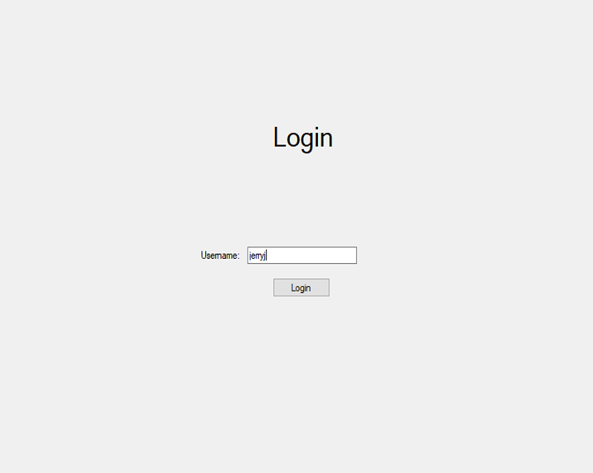Opening the coordinator will greet the user with a login form.

Depending on if the user is a manager or not will decided what form is shown to the user. Enter a username and select “Login”.

Manager

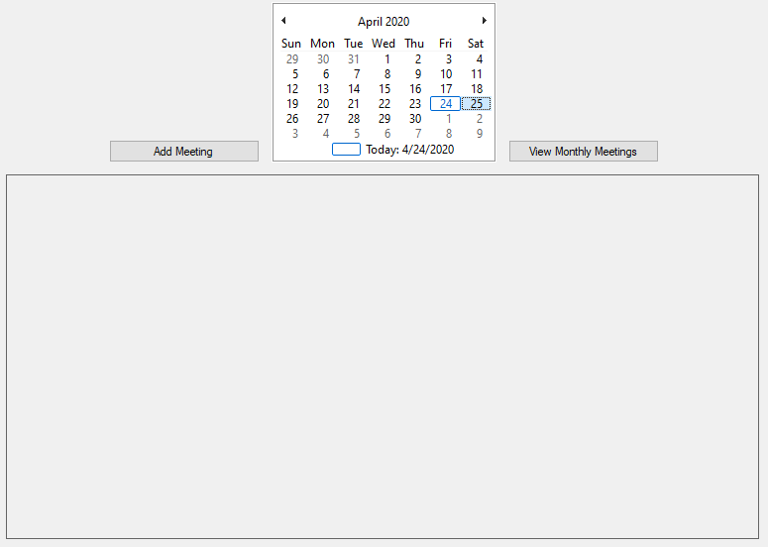The managers home layout will have an extra button to add meetings.

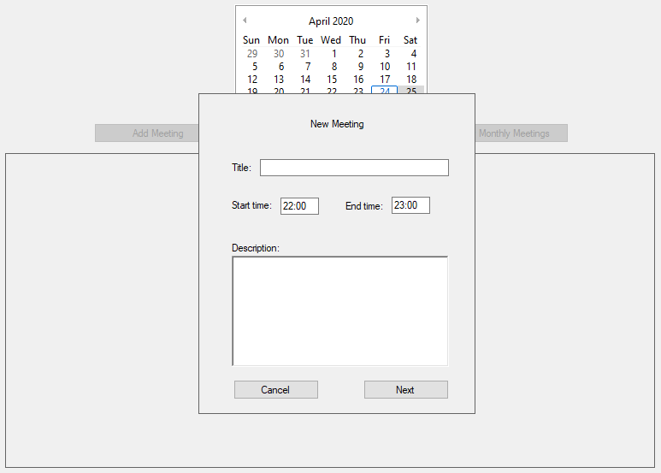Selecting a date on the calendar and then selecting “Add meeting” will allow the manager to create a meeting on that day.

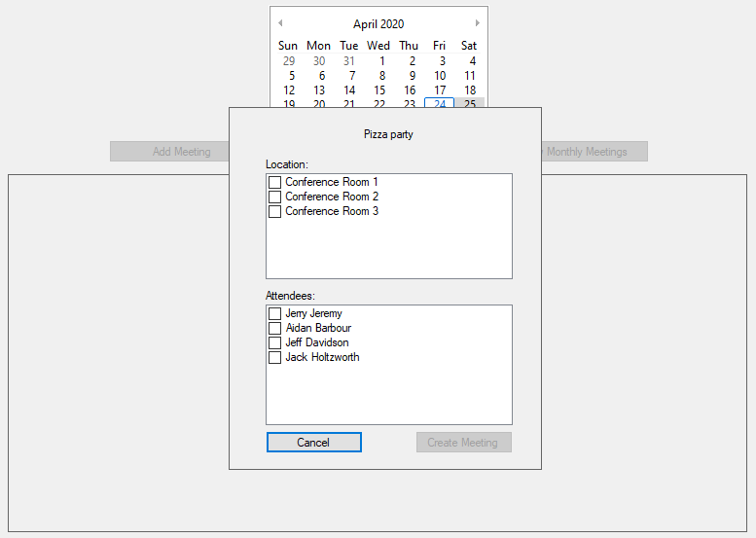Fill in the required information for the meeting and then select “Next” to move on to selecting time and attendees.

After selecting attendees and location of the meeting, select “Create Meeting” to finish creating the meeting.

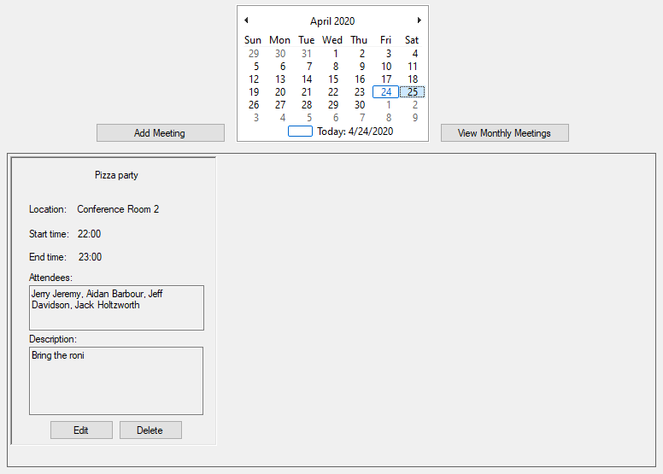The meeting will now show up in the space below the calendar.

Each meeting will have its own “Edit” and “Delete” button, to delete or edit a meeting select its “Delete” or “Edit” button.

The “View Monthly Meetings” button will display all meetings in a selected month. To select a month simply select any date that is in the month the user wishes to view.

To return to daily meetings Select “View Daily Meetings” in the same location as the “View Monthly Meetings”.

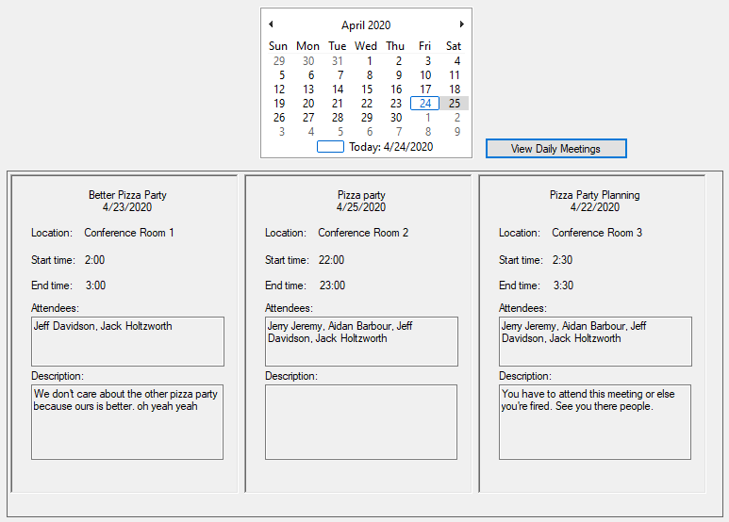

Employee

The employee home screen will not include the “Add Meeting” button.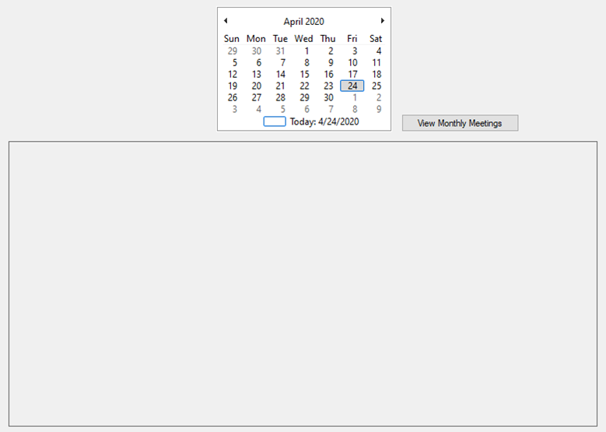

The employee will only be allowed to view meetings.

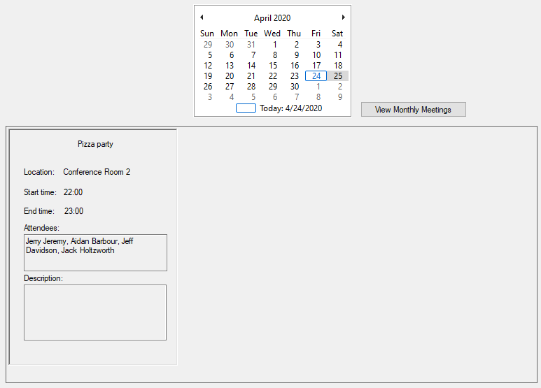To view a meeting simply select a day with a meeting on it and it will display all meetings on that day in the space below the calendar.

The employee will also not be allowed to edit or delete a meeting.

The “View Monthly Meetings” button will display all meetings in a selected month. To select a month simply select any date that is in the month the user wishes to view.

To return to daily meetings Select “View Daily Meetings” in the same location as the “View Monthly Meetings”.

